Question2

Designing a continuous delivery pipeline for Digibank, automate the entire process, from the time the development team gives us the code and commits it to the time we get it into production. We will automate the pipeline in order to make the entire software development lifecycle in DevOps/automated mode. For this, we will need automation tools.

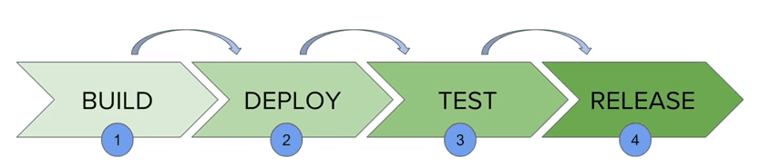

Jenkins provides us with various interfaces and tools in order to automate the entire process.

We have a Git repository where the development team will commit the code. Then, Jenkins takes over from there, a front-end tool where you can define your entire job or the task. Our job is to ensure the continuous integration and delivery process for that tool or for the application.

From Git, Jenkins pulls the code and then Jenkins moves it into the commit phase, where the code is committed from every branch. The build phase is where we compile the code. If it is Java code, we use tools like maven in Jenkins and then compile that code, which can be deployed to run a series of tests. These test cases are overseen by Jenkins again.

Then, it moves on to the staging server to deploy it using Docker. After a series of unit tests or sanity tests, it moves on to production.